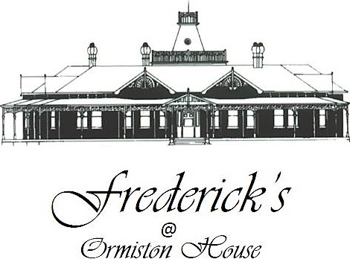

The house…

Frederick Ormiston Henry arrived on the West Coast of Tasmania with just 100 pounds in his pocket. Within ten years he had become one of the wealthiest men in Tasmania.

F.O. established his first trading store at an area now known as Smith's Cove - the start of the town of Strahan. He had stores in all of the mining towns on the West Coast. He acquired 2,067 £1 shares in the Mt Lyell mine and sold them in 1897 for £16-10s per share. A tidy sum indeed for those days. He then set about to build the grandest mansion on the West Coast and one of the finest examples of federation architecture in Australia.

On the 5th of June 1899 F.O. signed a contract with William McDonald, a builder, to build a fine home to the design of architects A & S Luttrell. The contract stated that the completion date was to be the 16th of November 1899 and that the builder was under a penalty of £5.0.0 for every week delay after that date. We believe that no penalty was paid and the house was ready for occupancy by the allocated time.

The rooms in Ormiston House have been retained, for the main part, as being sympathetic to their original use. The front rooms were all living and entertaining rooms. The library and music room are now Frederick’s Restaurant. F. O.'s den is now the bar and lounge.

F. O.'s bedroom is still the master bedroom and all bedrooms have been named after the original members of the Henry Family. F. O. Henry, Mary Alice, Amelia and Jessie. The restaurant is called Fredericks after the three Frederick Ormiston Henrys. The History Gallery, in the attic and well worth a look – simply ask one of our team for directions to the attic which is named after Harry Lyell Henry, the second son of F. O. who was tragically killed in action during the First World War.

The restaurant ..

Leslie and I moved from Australia to Strahan mid August 2015 to open our first Tasmanian venture Bushman’s, which we still own and operate opposite the cruise centre. We have always been on the lookout for other opportunities here in Strahan and after befriending Rose and Terry, the owners of the majestic Ormiston House, discussions were had to resurrect Fredericks after being dormant for more than a decade.

Our vision for Frederick’s is simple - refined dining, locally sourced ingredients, Tasmanian.

We have reinstated the kitchen garden out back where we grow organic herbs, micro salads, heirloom vegetables and selected native plants – garden to plate. Dean Hanson our butcher supplies beef and lamb directly from his property in Sassafras. Peter and Una Rockliff (Petuna) supply salmon directly from Macquarie Harbour and wild caught fish from the Southern Ocean. Torsten Schwoch fills our tanks with live crays from the pristine waters of the West Coast. We forage native plants from land and sea sourced from Macquarie Heads, Henty Dunes, Trial Harbour and surrounding areas.

Our premium wine list, 100% Tasmanian has been specially selected to show case the best of the best with the assistance of Darren McKenna from David Johnstone and Associates.

Thank you for dining with us

Leslie and Steve



Bintje potatoes, garlic confit



Local red velvet crab, cutting grass taco, green mango, black bean, chive shoots

$28.50

Local trout, dashi custard, wasabi and soy jelly, popped pork, sea celery (c)

$28.50

Local crayfish, carrot, sea butter, smoked olives and foraged leaves (c)

$28.50

Wallaby carpaccio, squid ink brioche, curry apple, horseradish, mustard seeds

$28.50

We pay respect to the traditional and original owners of this land the Lowreenne and Mimegin people, of the Toogee tribe, - to pay respect to those that have passed before us and to acknowledge today’s Tasmanian Aboriginal people who are the custodians of this land.



Sourdough, duck river butter



Heirloom tomato tart, dehydrated olives, goat curd, wild thyme (v)

$32.50

Saddleback pork, soured onions, crisp cauliflower, wild cabbage (c)

$38.50

Beef fillet, burnt pepperberry leaf, smoked bone marrow, beef tendon

salt baked and raw beetroot, veal jus (c)

$44.50

“Roasted” Marion Bay chicken, sweetcorn polenta,

pistachio, asparagus (c)

$38.50

Paillard of Petuna Salmon, roasted vine ripened tomatoes,

spring onion, chive beurre blanc (c)

$40.50

Sassafras 3 point rack, almond milk farro, heirloom carrots, crisp sweetbreads, olive caramel

$40.50

**Sides**

Cocktail potatoes, garlic, thyme

Seasonal steamed vegetables

$8.50

(c) Gluten Free (v) Vegetarian



$22.50

Show me the honey

Ginger & honey syrup cake

Native pepper berry & manuka honey ice-cream

White chocolate and honeycomb panna cotta

Lime curd, honey candy

The pine gardens

Lavender, green tea, chocolate, almond, blackberry,

twigs, pine & moss

Self serve

I’m not sharing!

Think golden think gaytime – caramel ice-cream, hazelnut chocolate mousse,

salted caramel crumble and a pinch of fairy dust

A touch of blue – before and after

Ashgrove’s Mr Bennett’s blue, Chromy pinot jelly, figs, walnut nougatine